**SOURCE CODE**

1. **import** pygame
2. **import** sys


6. **def** ddaLine(x1,y1,x2,y2):
7. dx **=** x2 **-** x1
8. dy **=** y2 **-** y1
10. **if**(dx>dy):
11. steps **=** abs(dx)
12. **else**:
13. steps **=** abs(dy)
15. xinc **=** dx **/** steps
16. yinc **=** dy **/** steps
18. x **=** x1
19. y **=** y1
21. **for** i **in** range(int(steps) **+** 1):
22. screen.set_at((round(x), round(y)), WHITE)#plot(int(x), int(y))
23. x **=** x **+** xinc
24. y **=** y **+** yinc


28. pygame.init()
29. WIDTH **=** 800
30. HEIGHT **=** 600
32. screen **=** pygame.display.set_mode((WIDTH, HEIGHT))
34. pygame.display.set_caption("DDA Line Drawing Algorithm")
36. WHITE **=** (12, 15, 255)
37. BLACK **=** (255, 255, 255)

40. **def** main():
41. **while** True:
42. **for** event **in** pygame.event.get():
43. **if** event.type**==**pygame.QUIT:
44. pygame.quit()
45. sys.exit()
46. screen.fill(BLACK)
47. ddaLine(25, 125, 700, 222)
48. pygame.display.flip()
49. pygame.time.delay(100)
51. **if** __name__ **==** "__main__":
52. main()

**OUTPUT**

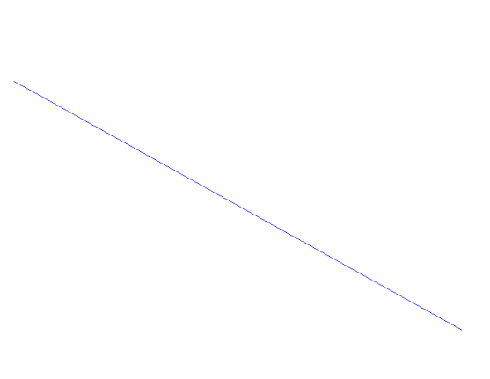

*Fig 2.1. Output of DDA Line Algorithm*